For Heat-Related Events Only
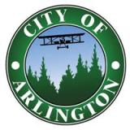
PAYMENT ARRANGEMENT

I hereby agree to the following payment arrangement:

Name __________________________________________________

Address ________________________________________________

Account # _______________________________________________

I agree to pay $___________________

Payment arrangement end date________________
(no later than May 15th of the following year)

Signature ________________________________ Date____________

Account #______________ Amount $___________ End Date_______

City staff is authorized to offer a payment arrangement during heat-related weather events. This agreement is a “promise to pay” the past due balance in full before May 15th of the following calendar year (at the latest). This is a one-time agreement and no late fees or shut off fees will be applied during the payment arrangement period as long as the terms are being met. This agreement must be in place in order for your water to be turned back on. If the past due payment is not received by the above end date your water will be disconnected immediately.

