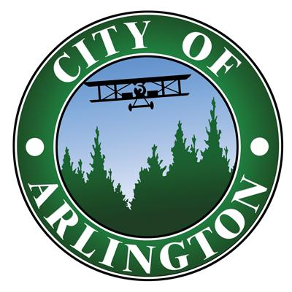
CITY OF ARLINGTON

CIVIL SERVICE COMMISSION
MEETING AGENDA

Wednesday, January 3, 2024 at 9:00 A.M.
Butner Board Room, 110 E. 3rd St
Public Virtual Meeting Attendance Option via Zoom:
https://arlingtonwa.zoom.us/j/88658704128?pwd=S2NJWCtKalg2OEY2TXJBMjhvclJtdz09
________________________________________________________________________________
CALL TO ORDER

ROLL CALL

APPROVAL OF THE AGENDA

VISITORS
Anyone wishing to speak on any matter not appearing on the agenda may do so at this time. The amount of time available to each speaker and the number of speakers is limited. Public comment on agenda items will be taken when the item is considered.

CONSENT AGENDA
- Meeting Minutes for December 6, 2023 ATTACHMENT A

NEW BUSINESS
- Election or Re-election of Chair and Vice Chair for Commission
- Appointment of Shawn Friang, HR Director, to Civil Service Secretary/Chief Examiner
- Police Department Report
  - Personnel actions
  - Recruitment
  - Notification of Lateral Officer Oral Board Scoring Results Certified, Chief’s interview, moved to background, December 15, 2023 ATTACHMENT B
  - Certify Entry Level Police Officer Eligibility List ATTACHMENT C
  - Entry Level Police Officer Eligibility List of Removals ATTACHMENT D

CONTINUED BUSINESS

ADJOURNMENT

Next meeting: February 7, 2024 at 9:00am

2024 Remaining Meetings @ 9:00 a.m.
  - February 7, 2024
  - March 6, 2024
  - April 3, 2024
  - May 1, 2024
  - June 5, 2024
  - July 3, 2024
  - August 7, 2024
  - September 4, 2024
  - October 2, 2024
  - November 6, 2024
  - December 4, 2024

